Djibouti

## Freedom House political status

The data set shows the Freedom House political scores and status of the country each year.

## # A tibble: 19 x 5  
## country iso3c date mean status   
## <chr> <chr> <dbl> <dbl> <chr>   
## 1 Djibouti DJI 1996 5.5 Not Free   
## 2 Djibouti DJI 1998 5.5 Not Free   
## 3 Djibouti DJI 2000 4.5 Partly Free  
## 4 Djibouti DJI 2002 4.5 Partly Free  
## 5 Djibouti DJI 2003 5 Partly Free  
## 6 Djibouti DJI 2004 5 Partly Free  
## 7 Djibouti DJI 2005 5 Partly Free  
## 8 Djibouti DJI 2006 5 Partly Free  
## 9 Djibouti DJI 2007 5 Partly Free  
## 10 Djibouti DJI 2008 5 Partly Free  
## 11 Djibouti DJI 2009 5 Partly Free  
## 12 Djibouti DJI 2010 5.5 Not Free   
## 13 Djibouti DJI 2011 5.5 Not Free   
## 14 Djibouti DJI 2012 5.5 Not Free   
## 15 Djibouti DJI 2013 5.5 Not Free   
## 16 Djibouti DJI 2014 5.5 Not Free   
## 17 Djibouti DJI 2015 5.5 Not Free   
## 18 Djibouti DJI 2016 5.5 Not Free   
## 19 Djibouti DJI 2017 5.5 Not Free

## Freedom House classification of political change

The data set shows the GDP growth and the ecomic growth classification of the country each year.

## # A tibble: 19 x 4  
## country iso3c date politicalChangeFH  
## <chr> <chr> <dbl> <chr>   
## 1 Djibouti DJI 1996 no change   
## 2 Djibouti DJI 1998 no change   
## 3 Djibouti DJI 2000 democratization   
## 4 Djibouti DJI 2002 no change   
## 5 Djibouti DJI 2003 autocratization   
## 6 Djibouti DJI 2004 no change   
## 7 Djibouti DJI 2005 no change   
## 8 Djibouti DJI 2006 no change   
## 9 Djibouti DJI 2007 no change   
## 10 Djibouti DJI 2008 no change   
## 11 Djibouti DJI 2009 no change   
## 12 Djibouti DJI 2010 autocratization   
## 13 Djibouti DJI 2011 no change   
## 14 Djibouti DJI 2012 no change   
## 15 Djibouti DJI 2013 no change   
## 16 Djibouti DJI 2014 no change   
## 17 Djibouti DJI 2015 no change   
## 18 Djibouti DJI 2016 no change   
## 19 Djibouti DJI 2017 no change

## Freedom House score trend

The plot shows the Freedom House scores trend of the country.

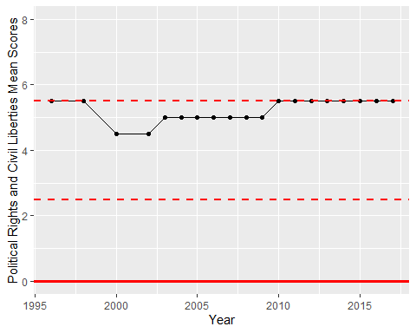

Freedom House Score Trend